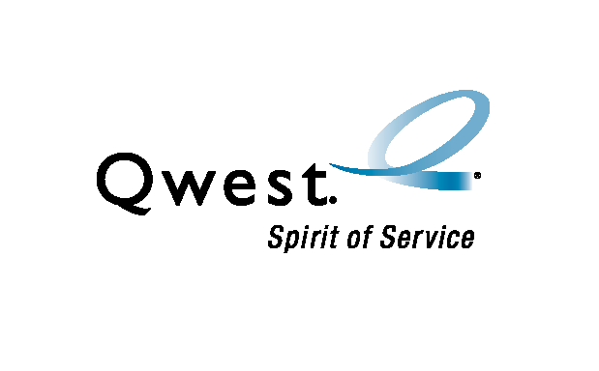
Super DaVaR upgrades

Meeting Minutes

Details | Date: Friday, November 7, 2003  Time: 1:00 PM MST  Place: 700 W. Mineral – Room 101E or 877-564-8688 id:278-1727

Attendees | - Ken Koch – Process Analyst  - Dave Bosley – Staff Engineer (Statistical Analysis)  - Art Utech – FLUKE (Regional Acct Mgr)  - John Settembre – AZ (Manager)  - Cynthia Parker – AZ (DaVaR SPOC)  - Al Lundy – AZ (DaVaR Tech) | - DJ Cameron – AZ (DaVaR Tech)  - Jerry Bourdeaux – MN (DaVaR SPOC)  - Greg Snyder – MN (Manager)  - Will Finley – OR (DaVaR Tech)  - Matt Klump – OR (DaVaR Tech)  - Jim Thomas – UT (Director)

Purpose | Communicate status for upgrading DaVaRs

Summary | The following information was updated during the meeting.
 | Topic | Information
 | Super DaVaR trial | Discovered that Super DaVaR settings for detecting ‘busy’ and ‘faults’ needed to be adjusted. FLUKE has determined correct settings and re-testing has begun:  CO - DNVRCOCL completed frame sweep on 11/07  AZ - SCDLAZMA started frame sweep on 11/4  AZ - SPRSAZMA will start when SCDLAZMA completes.  Need to be complete on 11/14.  Need to resolve resource issue in AZ to add 2nd and 3rd shifts.  Over-nighting 2 additional Super DaVaR on Monday.
 | IT Qwest Image for Super DaVaR | Colorado’s Super DaVaR is available again for IT to finish creating the Qwest Image – add Outlook (email) and access to WFA system.
 | Super DaVaR XP | XP process for creating Super DaVaR program to correct load coil information in LFACS and OSP-FM is still on schedule to complete in the first 90-day iteration – due 01/29/04.

Actions items | The following actions are required.
 | Topic | Who’s Responsible | Due
 | DaVaR inventory/techs (received most) | Each State to Ken Koch | 09/19/2003
 | Complete Qwest Image for DaVaR | Ken Koch / Roy Gonzalez | 11/14/2003
 | Complete SCDLAZMA and SPRSAZMA sweeps | Cynthia Parker | 11/14/2003

Next meeting | Friday, November 14, 2003  1 PM – 2 PM MST  Mnrl: 101E or 877-564-8688 id: 278-1727

